Jack Rollinson

W7252829

CS150 Spring 2018

Module 13:

Project 1:

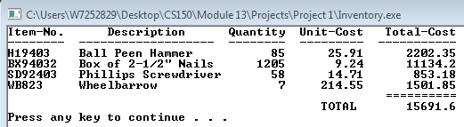

Project 2:

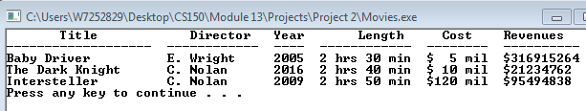

Lab 1:

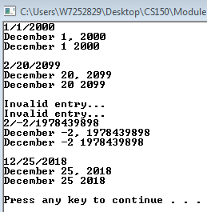

Lab 2:

